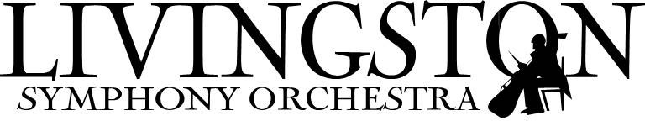

***2019 Young Artist Concerto Competition***

**$1,000 scholarship awarded annually!**

* **Auditions to be held on Saturday, February 2, 2019**

**(Livingston Public Library)**

* **Open to New Jersey residents,**

**14-21 years of age**

* **Applications due January 11, 2019**
* **Winner will receive $1,000, and will perform with the Livingston Symphony Orchestra on June 8, 2019**

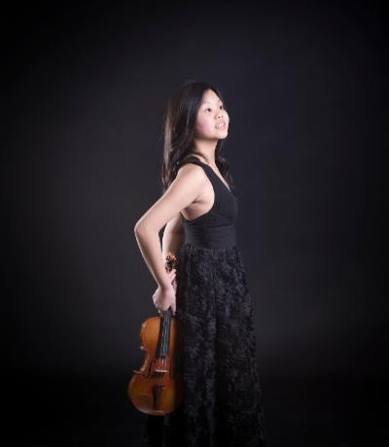

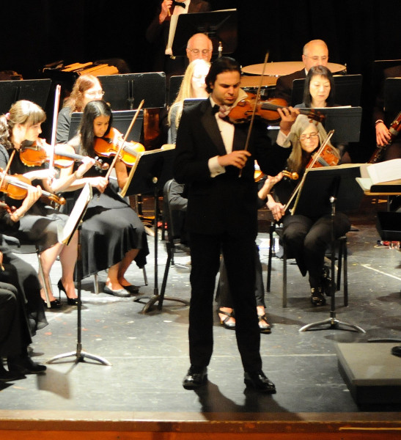

*2018 YACC Winner, Eilene Lee*

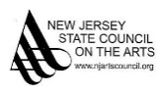

**Applications at** [**www.lsonj.org**](http://www.lsonj.org)

***For more information call (973) 886-9525***

*2017 YACC Winner, Asher Wulfman*

 Livingston Symphony Orchestra-NJ

 @livingstonsymphonynj